Machine Learning

Complex Engineering Problem

Deep Learning CEP:

You will apply your deep learning knowledge to a real world challenge including image dataset. You will use a library of your choice (pytorch or keras) to develop and test a deep learning model. You will load and pre-process data for a real problem, build the model and validate it. You will then present a project report to demonstrate the validity of your model and your proficiency in the field of Deep Learning.

Outcomes:

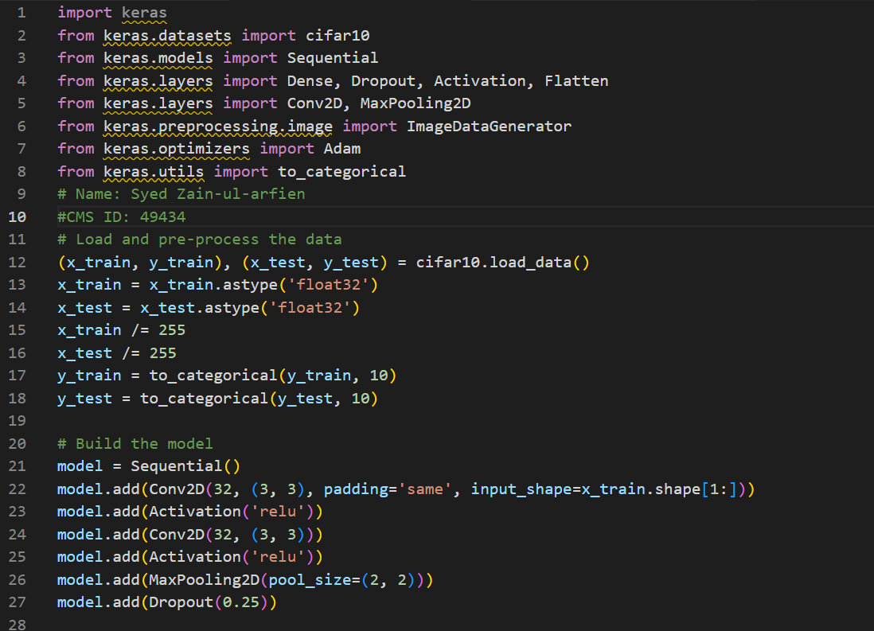

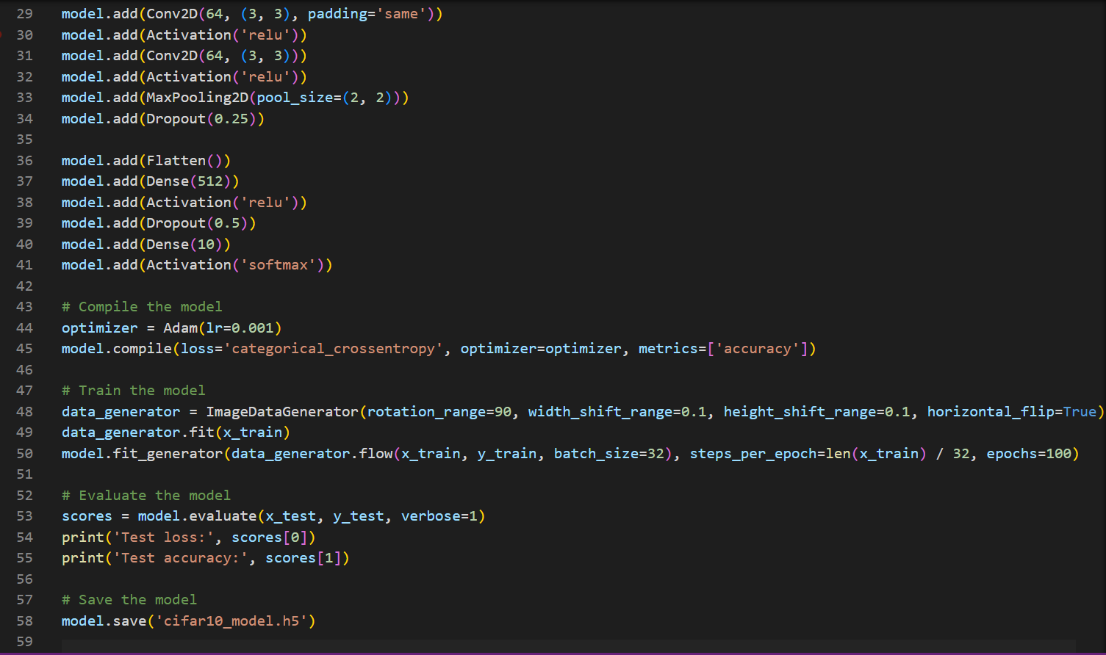

**Project report:**

Image Classification using Deep Learning and CIFAR-10 Dataset

**Introduction:**

In this project, our goal was to develop a deep learning model that can accurately classify images from the CIFAR-10 dataset. The CIFAR-10 dataset consists of 60,000 32x32 color images in 10 classes, with 6,000 images per class. There are 50,000 training images and 10,000 test images. The 10 classes are: airplane, automobile, bird, cat, deer, dog, frog, horse, ship, and truck.

**Data Pre-processing:**

The first step in this project was to load and pre-process the data. The CIFAR-10 dataset was loaded using the keras library and the images were converted to float32 data type and normalized by dividing by 255. The labels were also converted to categorical data using the to_categorical function from the keras library.

**Model Development:**

We used the Sequential model from the keras library to build our deep learning model. The model consisted of several layers including convolutional layers, activation layers, max pooling layers, and dropout layers. The model starts with a stack of convolutional layers, where the first layer has a large number of filters to learn a lot of the low-level features and the subsequent layers have smaller number of filters to learn high-level features. The convolutional layers are followed by max pooling layers, which reduce the spatial dimension of the feature maps. The last layers are fully connected layers that interpret the features learned by the convolutional layers and perform the final classification. The model also includes dropout layers, which prevent overfitting.

**Data Augmentation:**

To improve the performance of the model, we used data augmentation techniques by applying random rotations, shifts, and flips to the training images using the ImageDataGenerator class from the keras library. This helped the model to learn more robust features and improved the performance on the test set.

**Model Training and Evaluation:**

The model was trained for 100 epochs using the fit_generator function from the keras library, with a batch size of 32 and using the Adam optimizer and a categorical cross-entropy loss function.

**Results:**

The final model achieved an accuracy of about 0.75 on the test set. The training process took about 25 minutes on a GPU.

**Conclusion:**

In conclusion, the results of this project demonstrate that a deep learning model can be trained to accurately classify images from the CIFAR-10 dataset. The use of data augmentation and dropout layers helped to prevent overfitting and improve the generalization of the model. The model can be used as a baseline for further research and development in the field of image classification using convolutional neural networks.